Introduction to CAD- The Magic Sketchbook

Imagine opening a magic design space on the computer where your ideas can turn into real designs. This is called CAD – Computer-Aided Design or CAD for short

Intro to CAD
CAD stands for Computer-Aided Design. It is a fun way to draw, build, and design
using a computer.
Think of CAD as a magic sketchbook on the screen. Instead of pencils and paper,
you use shapes to create designs. You can make the shapes bigger, smaller, taller, or
wider and join them together to form 3D models.
People use CAD to design many things we see around us, such as toys, buildings,
vehicles, and traffic lights. In this course, you will use a CAD tool called Tinkercad
to turn your ideas into 3D designs.

Applications of CAD
CAD is used to design many things we see in our daily life. Few of them are listed
below,
• Buildings and Houses: Architects use CAD to design homes, schools, and bridges
before they are built.
• Cars and Vehicles: Engineers use CAD to design cars, buses, and bicycles.
• Toys and Games: Many toys are first designed using CAD before they are made
in factories.

• Machines and Gadgets: CAD is used to design phones, fans, and other machines
we use every day.
• Traffic Lights and Road Signs: CAD helps design traffic lights and road signs
that keep people safe on the road.

Machines and Gadgets: CAD is used to design phones, fans, and other machines
we use every day.
• Traffic Lights and Road Signs: CAD helps design traffic lights and road signs
that keep people safe on the road.

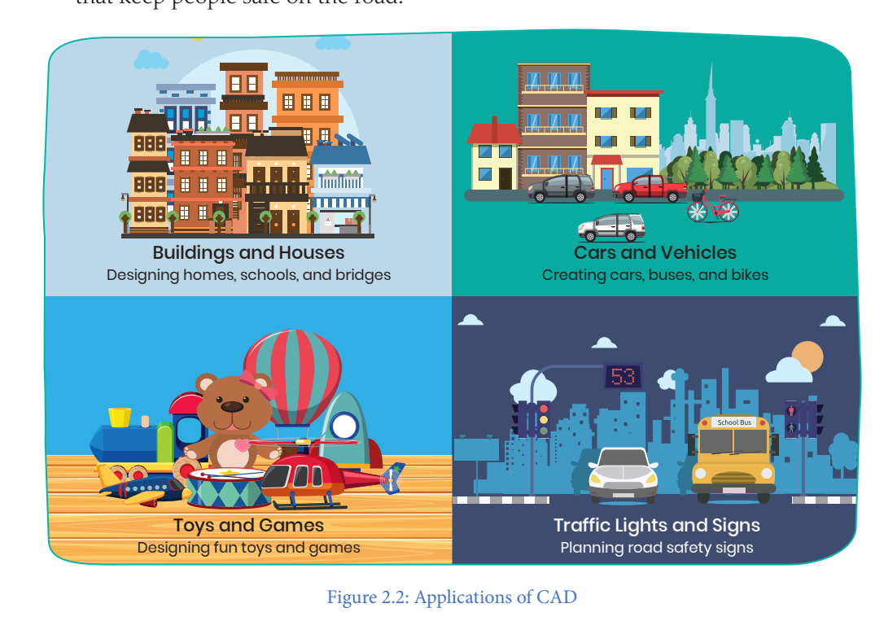
Intro to TinkerCAD
Tinkercad is a fun and easy tool that helps you create designs on a computer. It is a
CAD tool specially made for beginners.
In Tinkercad, you can build models using simple shapes. You can make the shapes
bigger or smaller, change their colors, and join them together to create 3D designs. It
is a great place to start your journey as a young designer

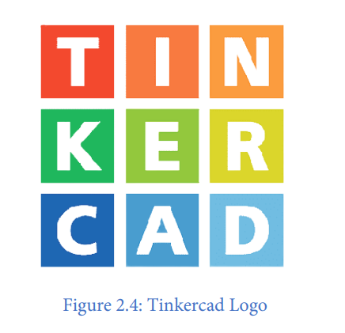
With Tinkercad, you can create a 3D model of a house with walls, windows, a roof,
and even furniture inside. You can explore different designs, add colours to the walls
and roof, and imagine how your dream house would look in real life

Tinkercad’s capacity to transform imagination into reality through enjoyable and
interactive experiences makes it an excellent option for learning CAD.
It teaches you valuable skills in spatial thinking, creativity, and problem-solving while
allowing you to express your ideas through digital design.

Tinkercad’s login process

Introduction to Shapes

In Tinkercad, we use such shapes to create 3D objects, just like buildings with blocks!
You can drag, drop, and combine these different shapes to make anything you imagine.
Here are some shapes you’ll find in Tinkercad.
Cube – A box for making buildings or tables.
Sphere – A ball for making planets or snowmen.
Cylinder – A tube for making wheels or cans.
Cone – A pointed shape for making trees or hats.

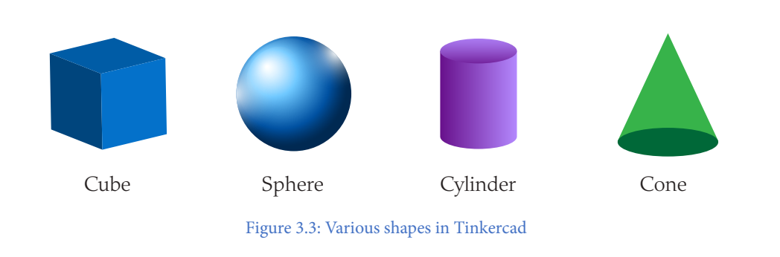

How do we build objects using these shapes in tinkercad workspace? That’s where
the Coordinate system comes in.

Coordinate system
Imagine you’re playing a treasure hunt game. Hence, you need a map to find the
treasure! In Tinkercad, the co-ordinate system is like a map that helps you place,
move, and build your 3D objects correctly.
Here’s how it works.
To place or move the object from side to side, the X-axis (Left & Right) is used. For
example, sliding a toy car on a table sideways.
To place or move the object front and back, the Y-axis (Forward & Backward) is used.
For example, stepping forward or backward.

To place or move the object higher or lower, the Z-axis (Up & Down) is used. For
example, lifting a balloon up or dropping it down.
All these three axes X, Y and Z meet at an imaginary point called as an origin.

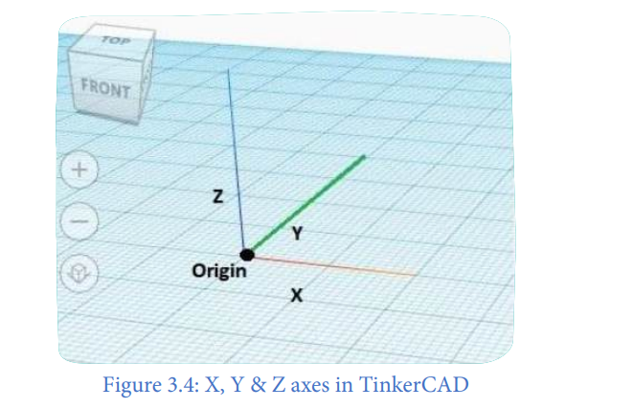

Remember, in Tinkercad, the green colour shows the Y-axis, the red colour shows
the X-axis, and the blue colour shows the Z-axis. Imagine you are standing inside
a room:
• X-axis (Red) is like moving left and right in the room
• Y-axis (Green) is like moving forward and backward
• Z-axis (Blue) is like moving up and down

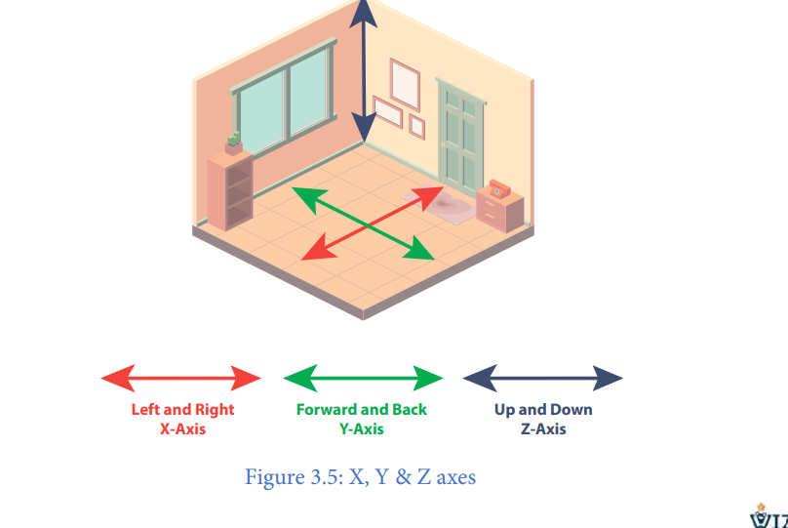

In Tinkercad, these three directions or the coordinate system help you build perfect
3D models. Now, let’s dive deeper into how we can use this system to create amazing
Designs

Drawings made on paper can be erased and drawn again, but they cannot be moved
from one place to another. In computer drawings, like the shapes in Tinkercad,
shapes can be moved easily using a special feature called the Move Block.
This makes designing faster and more fun! Let’s explore this.
Move block in Tinkercad
In Tinkercad, we can place and move 3D objects to create amazing designs! To move an object first, we need to add the object to the workspace right. Let’s do that.
